FitBuddy – AI Fitness Plan Generator
PROJECT DOCUMENTATION
Naan Mudhalvan – Project Documentation
FastAPI + Google Gemini + SQLite
TEAM MEMBERS
1. Aliya S (Team Leader) – aliya.beerthose.s.25ds003@gmail.com
2. Prithika S – prithika.s.25ds032@gmail.com
3. Sujithra P – sujithra.p.25ds042@gmail.com
4. Supriya V – supriya.v.25ds043@gmail.com

PROJECT OVERVIEW
FitBuddy is an AI-powered fitness plan generator developed using FastAPI, Google Gemini, SQLAlchemy, SQLite, Jinja2 templates, and Pydantic. The application collects basic user fitness information and generates a personalized 7-day workout plan based on the user's goal and preferred workout intensity.
The system also provides a quick nutrition or recovery tip using the lighter Gemini Flash model. Users can submit feedback about the generated plan, after which Gemini revises the relevant parts of the workout plan.

Main Features
- User fitness information collection
- Personalized 7-day workout plan generation
- AI-generated nutrition or recovery tip
- Feedback-based workout plan revision
- SQLite database storage using SQLAlchemy
- Admin dashboard for viewing all users and plans
- JSON API routes with FastAPI Swagger documentation
- Static files and Jinja2 HTML templates

OBJECTIVE
The main objective of FitBuddy is to provide a simple web-based fitness assistant that can generate personalized workout plans and practical nutrition or recovery tips using generative AI.

PROJECT INSTRUCTION
- FastAPI is used to create the web application and API endpoints.
- Google Gemini 1.5 Pro is used for structured workout plans and feedback-based revisions.
- Google Gemini 1.5 Flash is used to generate a quick nutrition or recovery tip.
- SQLite is used to store user information and workout plans.
- SQLAlchemy provides database models and database operations.
- Jinja2 templates are used to display the web interface.
- Pydantic models validate JSON API request data.

PRE-REQUISITES
- Python – required to run the application.
- FastAPI – used to build the web application and API.
- Uvicorn – used as the ASGI server.
- Jinja2 – used for HTML template rendering.
- SQLAlchemy – used for database models and operations.
- SQLite – used as the local database.
- Google Generative AI SDK – used to connect with Gemini models.
- Python-dotenv – used to load the Google API key from the .env file.
- VS Code or another Python IDE – used for development.
- A Google Gemini API key – required for AI generation.

TECHNICAL ARCHITECTURE
Layer | Technology / Component | Purpose
Application | FastAPI | Web application and REST-style API routes
Server | Uvicorn | Runs the FastAPI application
AI – Workout | Gemini 1.5 Pro | Generates structured 7-day workout plans
AI – Nutrition | Gemini 1.5 Flash | Generates a practical nutrition/recovery tip
AI – Revision | Gemini 1.5 Pro | Revises a plan using user feedback
Database | SQLite + SQLAlchemy | Stores users and workout plans
Validation | Pydantic | Validates JSON API request bodies
Frontend | Jinja2 + HTML | Displays input, result and admin pages

PROJECT ARCHITECTURE
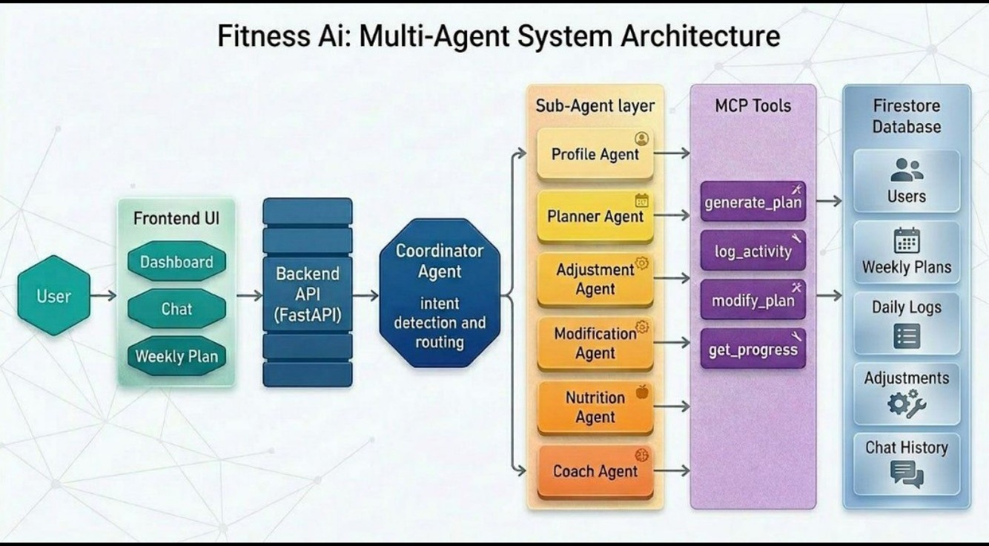
Figure 2. Reference multi-agent fitness system architecture
User
|
v
Jinja2 / HTML Interface
|
v
FastAPI Routes
|--------------------|
v v
Gemini AI SQLAlchemy
| |
v v
Workout / Tip SQLite Database
|
v
Generated Result / Revised Plan

DATABASE DESIGN
FitBuddy uses SQLite as its local database. SQLAlchemy is used to define the database models and perform read/write operations. The database is automatically initialized when the FastAPI application starts.

ENTITIES
Entity | Fields
User | id, name, age, weight, goal, intensity, schedule
WorkoutPlan | id, user_id, original_plan, updated_plan

USER TABLE
- id – primary key and user identifier
- name – user's name
- age – user's age
- weight – user's weight
- goal – selected fitness goal
- intensity – preferred workout intensity
- schedule – default 7-day schedule

WORKOUT PLAN TABLE
- id – primary key
- user_id – reference to the user
- original_plan – initially generated workout plan
- updated_plan – feedback-revised workout plan

RELATIONSHIP
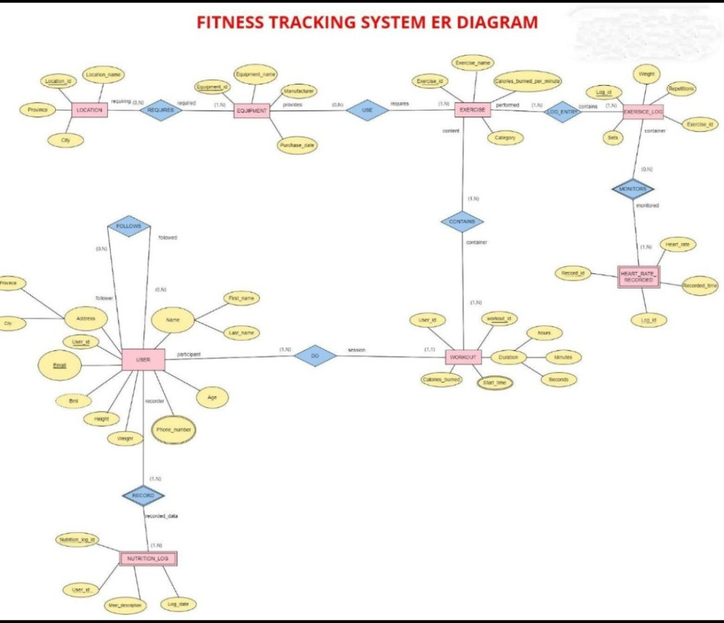
Figure 3. Fitness tracking Entity–Relationship diagram (reference)
USER
+----------------+
| id (PK) |
| name |
| age |
| weight |
| goal |
| intensity |
| schedule |
+-------+--------+
|
| user_id (FK)
v
+-------------------------+
| WORKOUT PLAN |
| id (PK) |
| user_id (FK) |
| original_plan |
| updated_plan |
+-------------------------+
FEATURES
Feature | Description
Fitness Input | Collects name, user ID, age, weight, fitness goal and workout intensity.
7-Day Workout Plan | Gemini 1.5 Pro generates a structured plan for Day 1 to Day 7.
Warm-up | Each day is requested to include a 5–10 minute warm-up.
Main Workout | The generated plan includes targeted exercises, sets and repetitions.
Cooldown / Recovery | Each day includes a cooldown or recovery tip.
Nutrition Tip | Gemini Flash produces one practical nutrition or recovery tip.
Feedback Revision | User feedback is sent to Gemini to revise the relevant plan sections.
Database Storage | User details and generated plans are stored in SQLite.
Admin Dashboard | All users and their latest plans can be viewed through a dashboard.
Swagger API | FastAPI exposes interactive API documentation at /docs.

ROLES AND RESPONSIBILITIES
Role | Responsibility
User | Enter fitness details, view generated plan, submit feedback.
AI Service | Generate workout plan, nutrition tip and revised plan.
Database | Store user information and original/updated plans.
Admin | View all stored users and plans through the dashboard.

USER FLOW
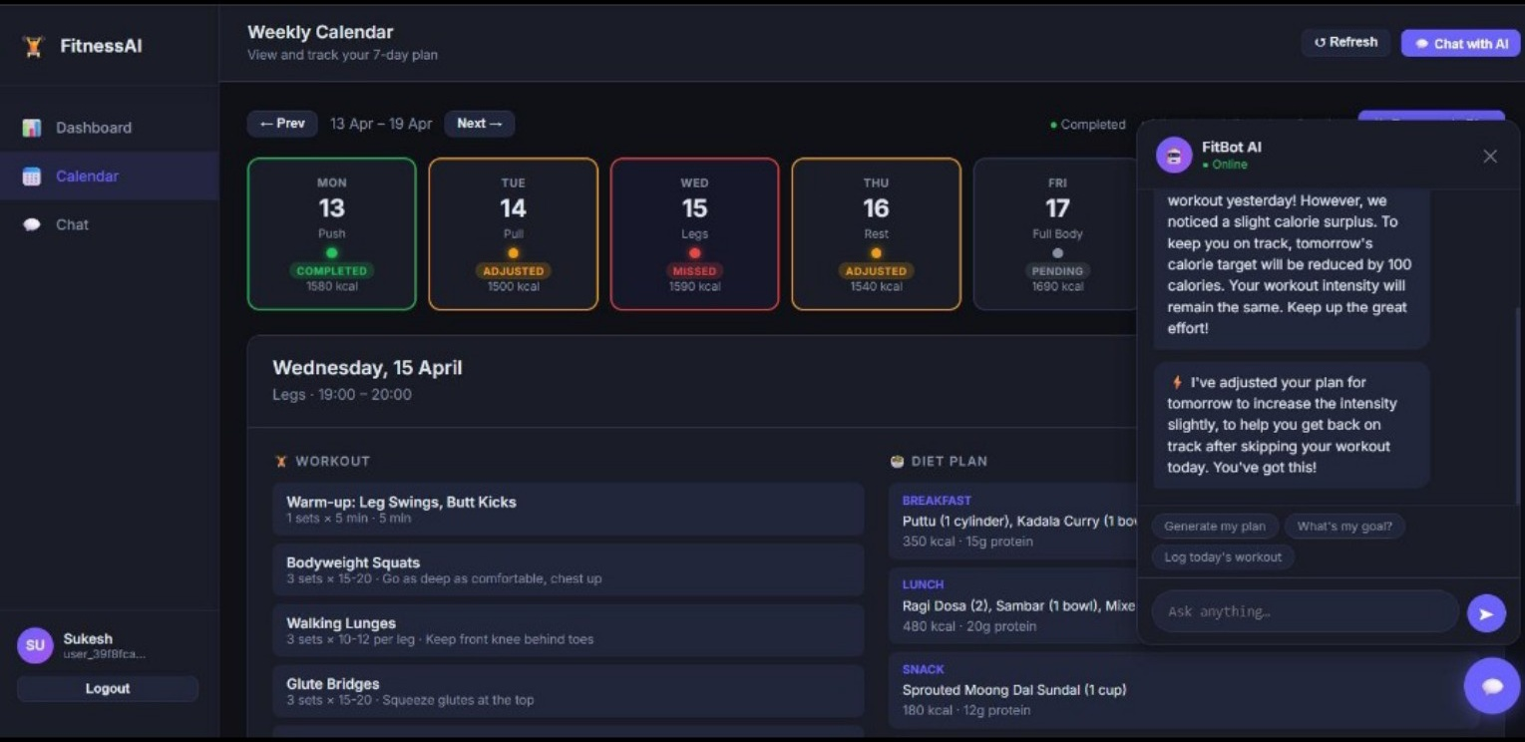
Figure 4. Reference weekly fitness plan and AI assistant interface
Enter Fitness Details
|
v
Generate Workout Plan
|
v
Generate Nutrition Tip
|
v
Save User + Original Plan
|
v
Display Result
|
v
Submit Feedback (optional)
|
v
Revise Workout Plan
|
v
Display Updated Plan

PROJECT SETUP AND CONFIGURATION

Folder Structure
fitbuddy/
├── requirements.txt
├── .env.example
├── app/
│ ├── main.py
│ ├── database.py
│ ├── schemas.py
│ ├── gemini_generator.py
│ ├── gemini_flash_generator.py
│ ├── updated_plan.py
│ ├── routes.py
│ ├── templates/
│ │ ├── index.html
│ │ ├── result.html
│ │ └── all_users.html
│ └── static/
│ └── images/
└── fitbuddy.db

Required Dependencies
fastapi
uvicorn[standard]
jinja2
sqlalchemy
python-multipart
google-generativeai
python-dotenv

Environment Configuration
A .env file is used to store the Google Gemini API key. The application loads this value using python-dotenv.
GOOGLE_API_KEY=your_actual_key_here

PROJECT SETUP

1. Create a Virtual Environment
python -m venv fitbuddy-env
fitbuddy-env\Scripts\activate
Purpose: To create an isolated Python environment for the FitBuddy project.

2. Install Required Dependencies
pip install -r requirements.txt
Purpose: To install FastAPI, Uvicorn, Jinja2, SQLAlchemy, Google Generative AI and other required packages.

3. Configure Gemini API Key
cp .env.example .env
# Add the actual Google Gemini API key in .env
Purpose: To securely provide the API key required for Gemini model access.

4. Start the Application
uvicorn app.main:app --reload
Purpose: To start the FastAPI development server with automatic reload enabled.

Important Application URLs
URL | Purpose
http://127.0.0.1:8000/ | Main fitness input form
http://127.0.0.1:8000/view-all-users | Admin dashboard
http://127.0.0.1:8000/docs | Interactive FastAPI Swagger UI

AI DEVELOPMENT

Workout Plan Generation
The workout generation module uses Google Gemini 1.5 Pro. The application sends the user's fitness goal and preferred intensity to the model.
Create a personalized, structured 7-day workout plan
Goal: user fitness goal
Intensity: user preferred intensity
Each day includes:
- Warm-up (5–10 mins)
- Main workout
- Targeted exercises, sets and reps
- Cooldown or recovery tip
The generated response is returned as text and stored as the original workout plan.

Nutrition / Recovery Tip
Gemini 1.5 Flash is used for a short nutrition or recovery recommendation. The prompt requests one clear, practical and friendly tip based on the user's fitness goal.

Feedback-Based Plan Revision
When a user submits feedback, the application retrieves the latest original plan and sends both the plan and feedback to Gemini 1.5 Pro. The model revises the relevant parts while keeping the remaining format and content unchanged where possible.
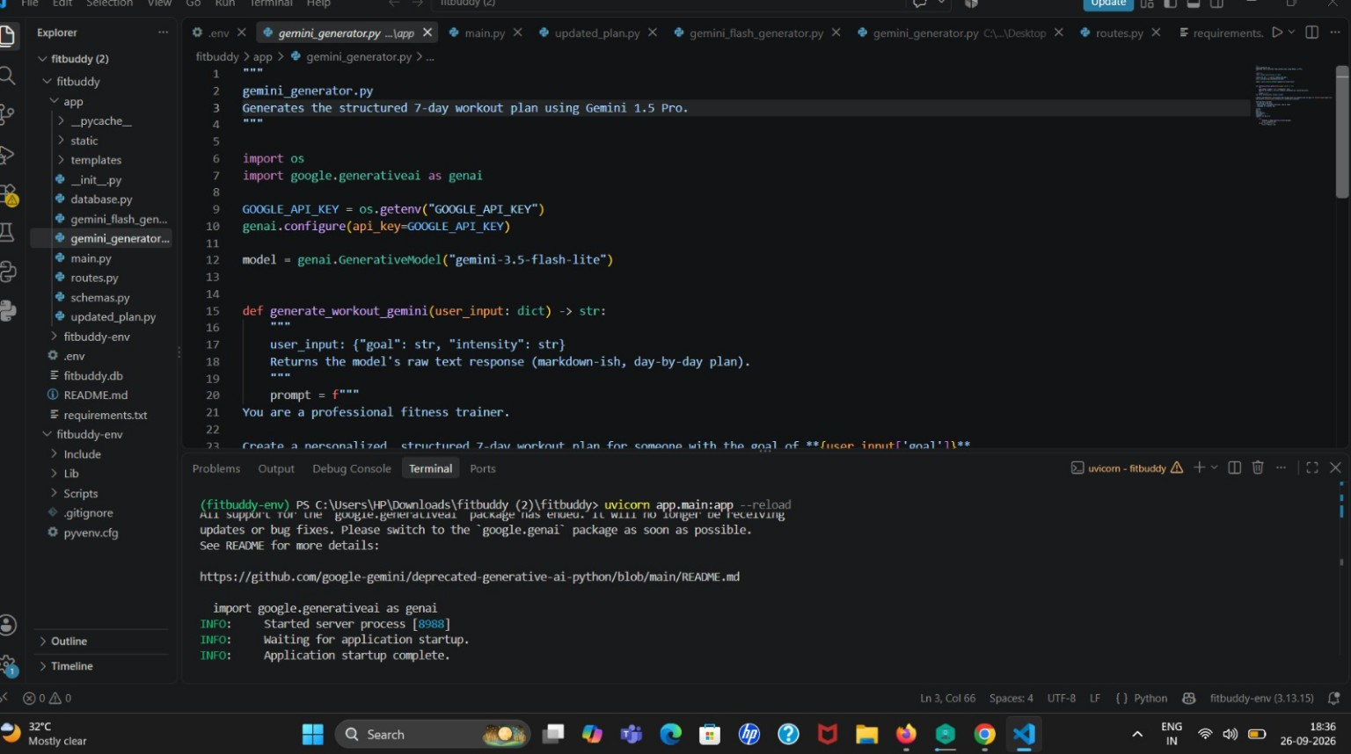
Figure: FitBuddy Gemini workout-generation code in VS Code.

AI Flow
User Goal + Intensity
|
v
Gemini 1.5 Pro
|
v
7-Day Workout Plan
User Goal
|
v
Gemini 1.5 Flash
|
v
Nutrition / Recovery Tip
Original Plan + Feedback
|
v
Gemini 1.5 Pro
|
v
Updated Workout Plan
BACKEND DEVELOPMENT

FastAPI Routes
Method | Route | Purpose
GET | / | Displays the main input form.
POST | /generate-workout | Generates and displays a workout plan and nutrition tip.
POST | /submit-feedback | Updates the workout plan using user feedback.
GET | /view-all-users | Displays all users and their plans in the admin dashboard.
POST | /generate-workout/gemini | JSON API for workout generation.
GET | /nutrition-tip | JSON API for a nutrition tip.
POST | /generate-plan | JSON API for generating and storing a plan.
POST | /update-plan/{user_id} | JSON API for feedback-based plan updates.

Database Operations
- init_db() creates the database tables when the application starts.
- save_user() stores or updates user fitness information.
- save_plan() stores a newly generated plan as the original plan.
- update_plan() stores the feedback-revised plan in the latest workout record.
- get_original_plan() retrieves the latest original plan for a user.
- get_user() retrieves a user record.
- get_all_users_with_plans() prepares data for the admin dashboard.

Request Validation
Pydantic models are used for JSON API inputs. UserInput contains username, user_id, age, weight, goal and intensity. FeedbackRequest contains feedback, while WorkoutRequest contains goal and intensity.

DATABASE DEVELOPMENT AND EXECUTION

Configure SQLite
The application uses a local SQLite database with the connection string sqlite:///./fitbuddy.db. SQLAlchemy creates the engine and session factory.

Create Database Tables
The init_db() function calls SQLAlchemy metadata creation so that the users and plans tables are created if they do not already exist.

Store User Information
When the workout form is submitted, the application saves the user's name, ID, age, weight, goal and intensity. Existing users with the same ID are updated.

Store and Update Plans
A newly generated plan is saved as original_plan. When feedback is submitted, the most recent WorkoutPlan record is updated with updated_plan.

PROJECT EXECUTION
- Create and activate the FitBuddy virtual environment.
- Install the required Python packages.
- Create the .env file and configure GOOGLE_API_KEY.
- Start the FastAPI application using Uvicorn.
- Open the main page at the local server address.
- Enter user fitness information.
- Generate the 7-day workout plan and nutrition tip.
- View the generated result.
- Submit feedback if the plan needs modification.
- View the revised plan and stored information through the application.

PROJECT OUTPUT

Main Application Output
The project provides an HTML input page where the user enters the required fitness information. After submission, the application displays the generated 7-day workout plan together with a nutrition or recovery tip.
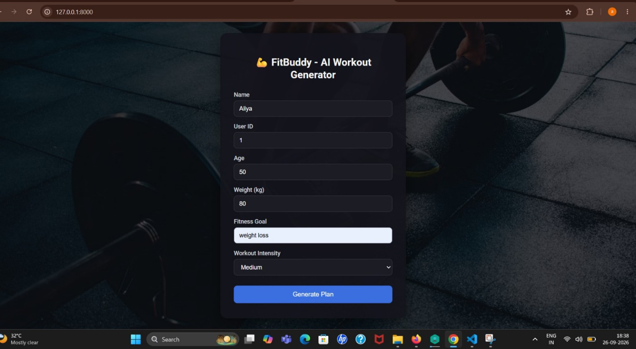
Figure: FitBuddy main application input page.

Workout Result
- User details are displayed with the generated result.
- The AI-generated workout plan is presented day by day.
- The nutrition/recovery tip is shown with the plan.
- A feedback option allows the user to request a revision.
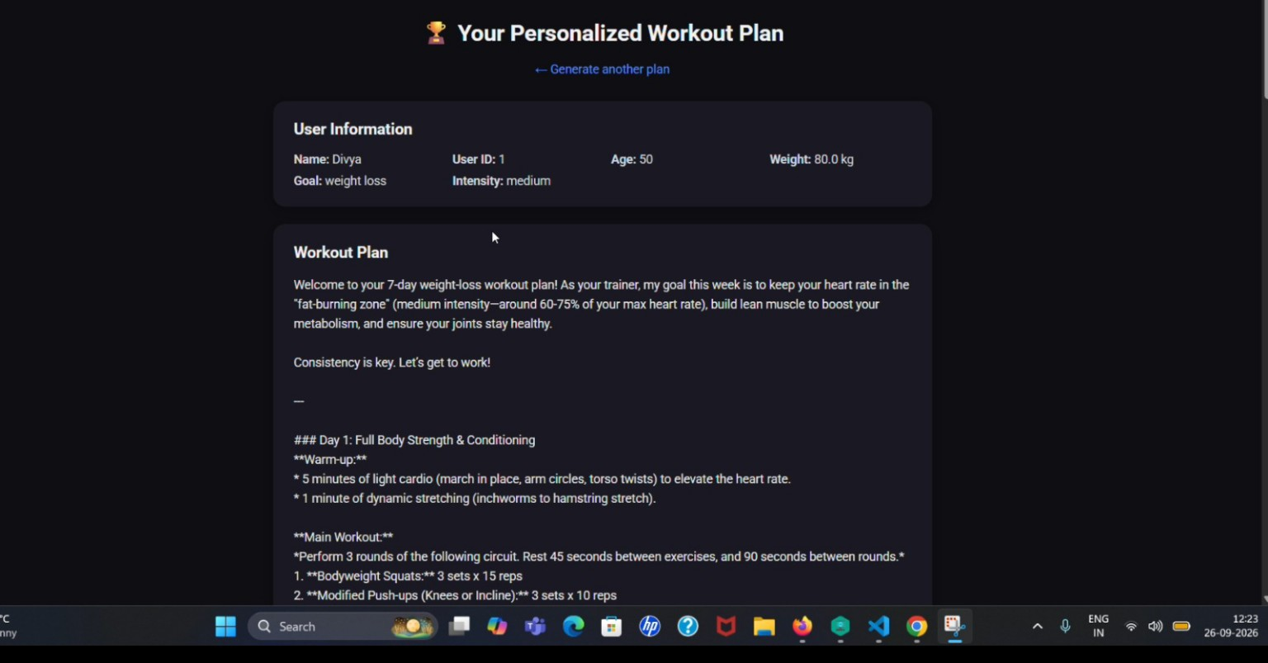
Figure: FitBuddy personalized 7-day workout plan output.

Admin Dashboard
The /view-all-users route displays stored users and their latest original and updated workout plans. This page is intended to provide an overview of the stored application data.

API Documentation
FastAPI automatically provides interactive API documentation at /docs. The JSON routes can be tested directly through the Swagger UI.

PROJECT VISUALS AND OUTPUT EVIDENCE
The project documentation should include actual application screenshots such as the home/input page, generated workout plan, nutrition/recovery tip, feedback revision, admin dashboard, and FastAPI Swagger /docs page. Reference visuals are included in the relevant technical sections above.

CONCLUSION
FitBuddy demonstrates how generative AI can be integrated into a web application to create personalized fitness recommendations. The system combines FastAPI for backend development, Google Gemini for AI-generated content, SQLAlchemy and SQLite for data storage, Pydantic for request validation, and Jinja2 for the user interface.
The application supports a complete flow from entering fitness information to generating a 7-day workout plan, providing a nutrition or recovery tip, storing the generated plan, and revising the plan based on user feedback.

LEARNING OUTCOMES
- Understanding FastAPI application and route development.
- Using Uvicorn to run a Python web application.
- Integrating Google Gemini models into an application.
- Creating structured prompts for generative AI.
- Using SQLAlchemy with SQLite for data persistence.
- Using Pydantic for API request validation.
- Rendering HTML pages using Jinja2 templates.
- Building feedback-based AI workflows.
- Testing APIs through FastAPI Swagger documentation.

FUTURE ENHANCEMENTS
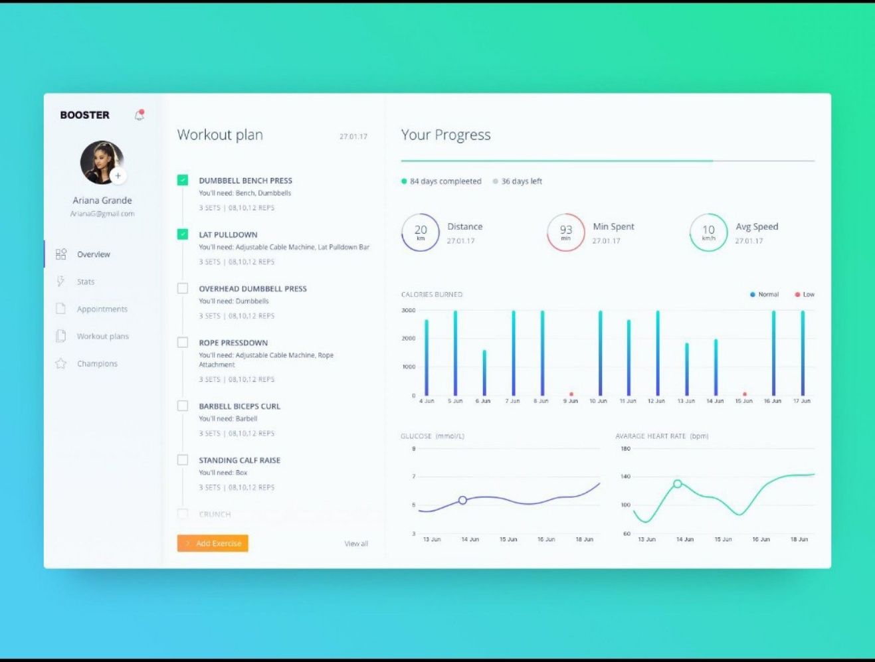
Figure 5. Illustrative progress-tracking dashboard for future enhancement
- Add user authentication and personalized accounts.
- Add richer progress tracking and workout history.
- Add more detailed nutrition planning.
- Add exercise images or demonstration videos.
- Add cloud database support for deployment.
- Add mobile-friendly or dedicated mobile application support.

REFERENCES
- Project source code and README provided for FitBuddy.
- FastAPI documentation – framework used for the backend.
- SQLAlchemy – ORM and database management library.
- Google Generative AI / Gemini – AI generation service.
- Jinja2 – HTML template rendering engine.
PROJECT REPOSITORY LINK
https://github.com/aliyabeerthoses25ds003-netizen/Fitbuddy-aliya

